FINGERPRINTING APPOINTMENT INSTRUCTIONS
You must complete the actual fingerprinting prior to your first day of work.

To schedule your appointment, follow the instructions below.
Go to: https://www.identogo.com/locations/massachusetts
Select Digital Fingerprinting
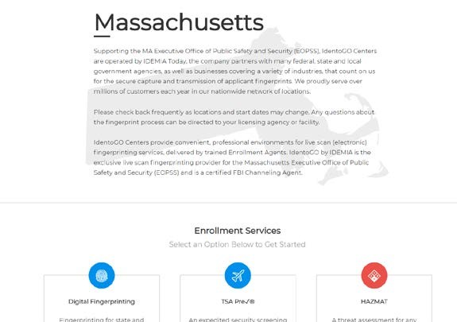
RESIDE IN MASSACHUSETTS: Select In State Digital Fingerprinting Services
RESIDE OUT OF MASSACHUSETTS: Select Out of State”Digital Fingerprinting Services

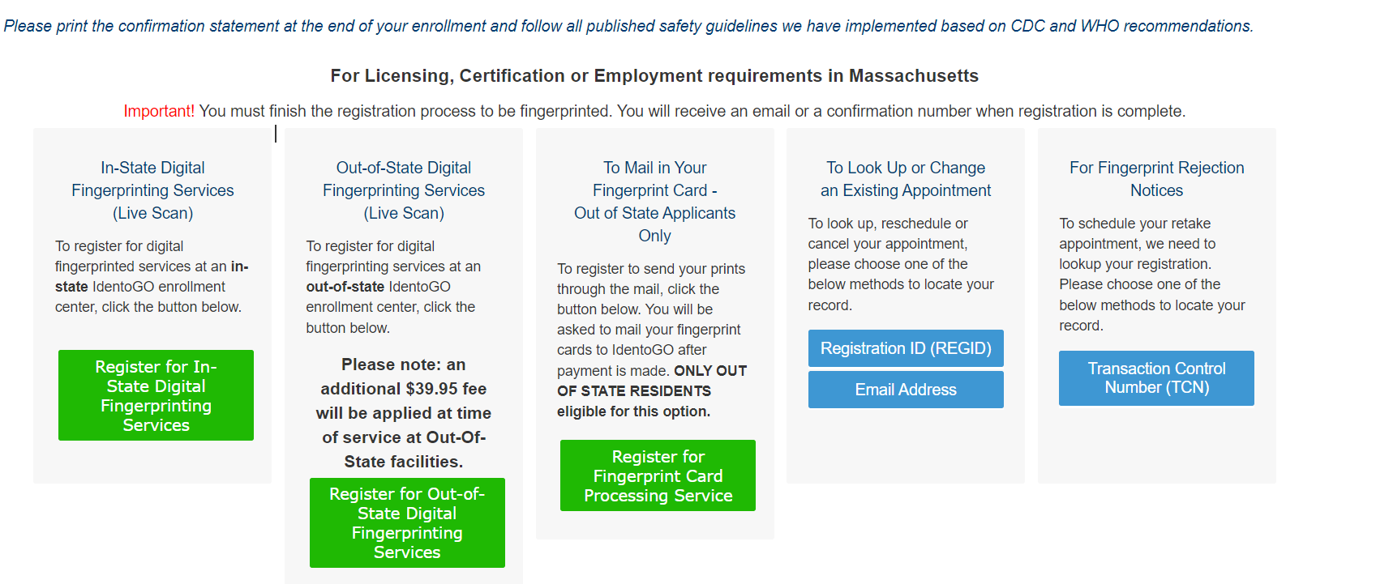

From the drop down menu, select Pre-K-12th Grade Education (ESE)
Click Go.
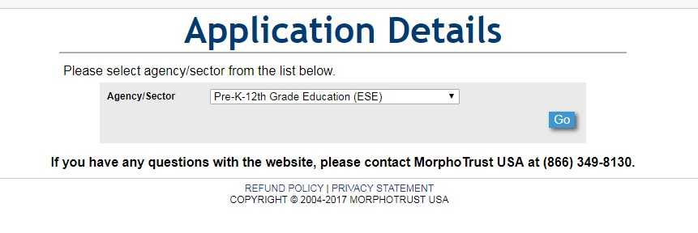

If you are a licensed educator, please select Licensed Educator, if not, select All Other School Personnel.
Click Go.

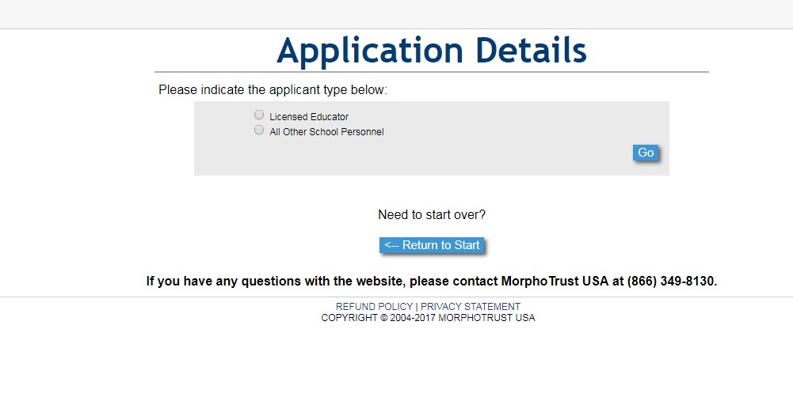
Confirm that you have selected the correct applicant type:

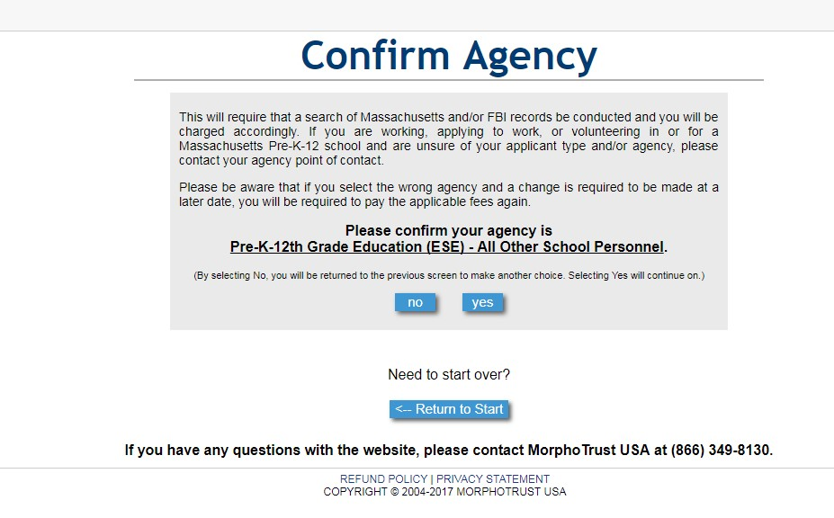

Enter the Provider ID of Phillips Academy: 00090820
Click Go.
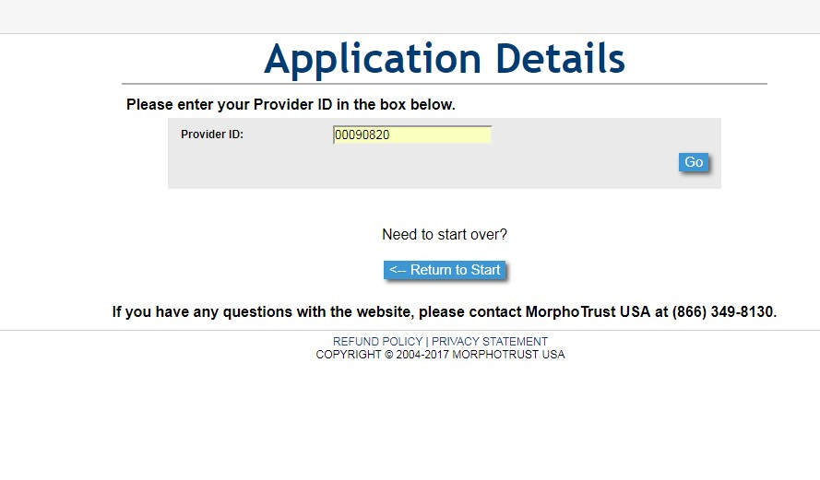

Confirm provider by selecting Correct (only if it shows that Phillips Academy was selected):

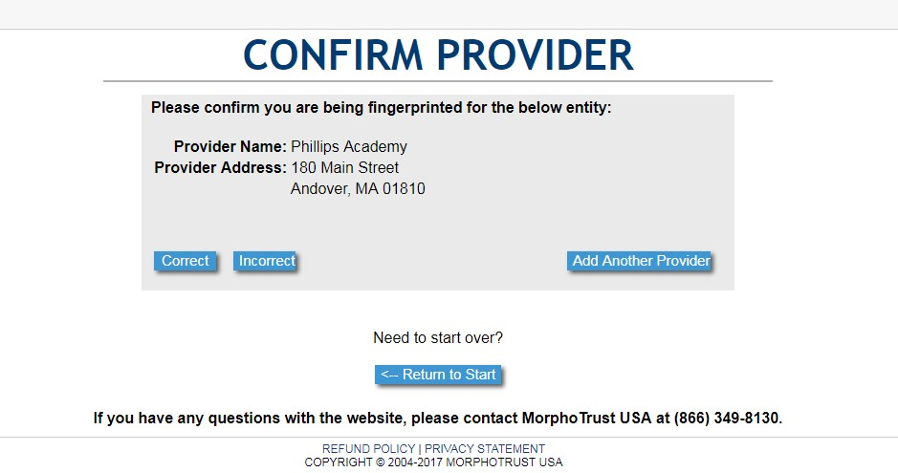
Enter zip code that you are in, to locate the closest fingerprinting location.
Click Go.

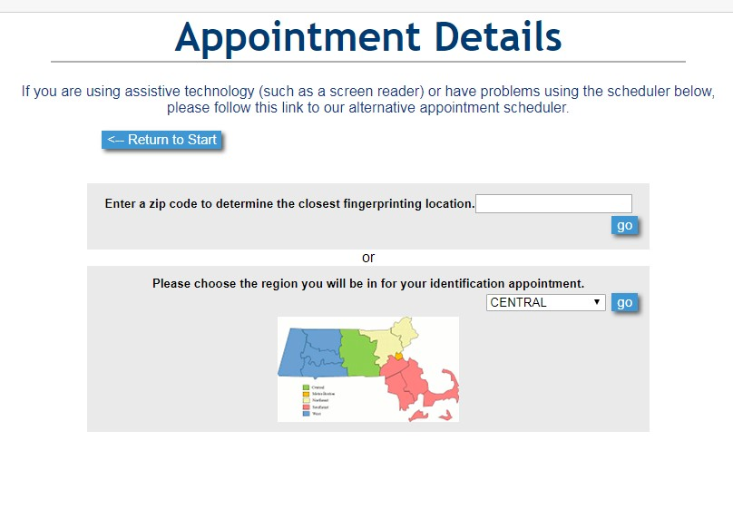

You will now have the option of selecting the date by navigating through dates/weeks by selecting “next week” at the top of the screen. By selecting Next near viewing page at bottom of screen, you will be taken to different locations.

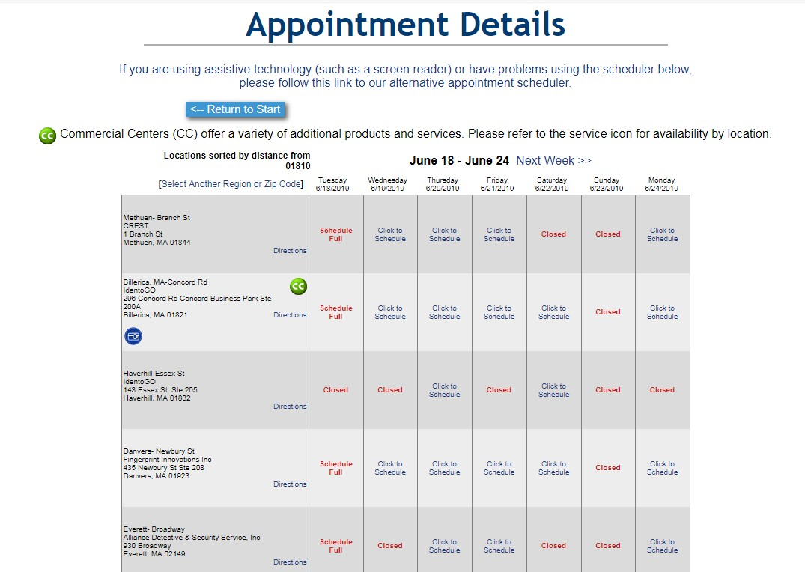
Select Click to Schedule to see options for different appointment times.

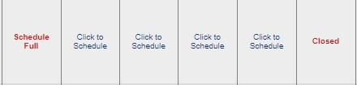

Read the Acknowledgement/Release and select appropriate box.
Click Go.
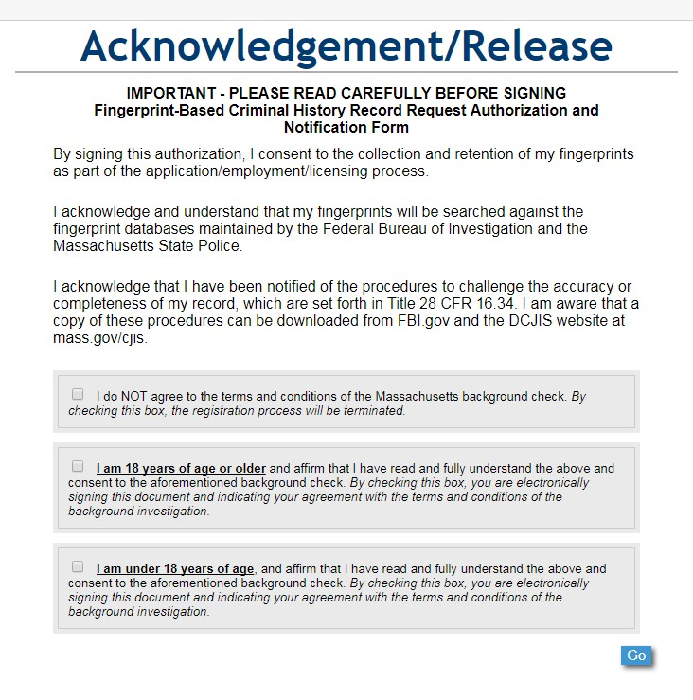

Complete the application information
Click Go.

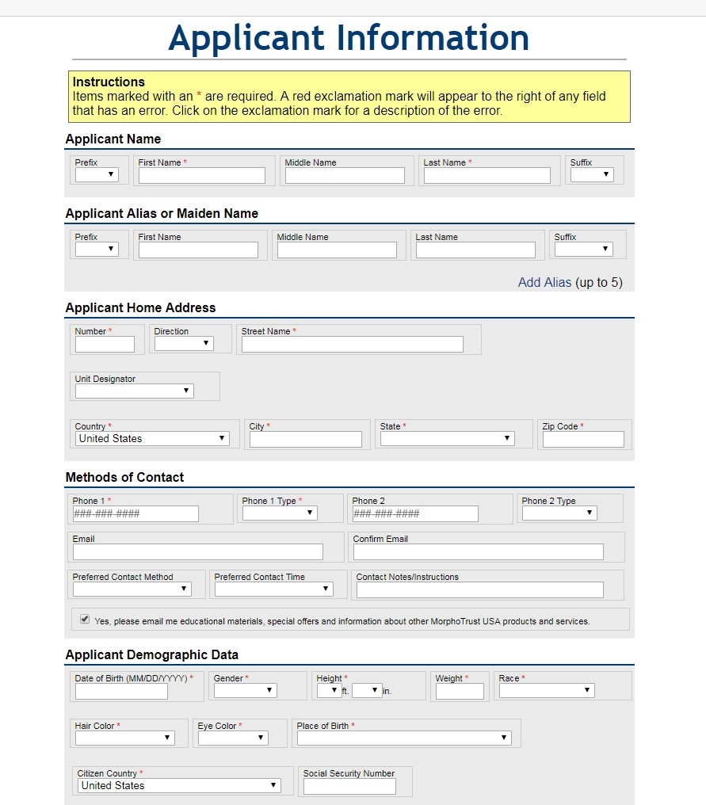

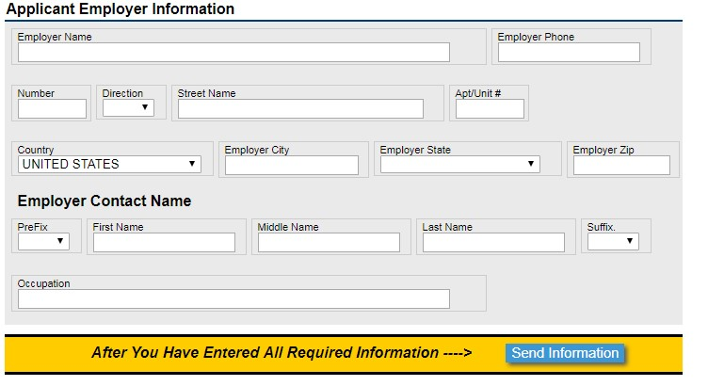

Select Send Information.

You will confirm the accuracy of your information, as well as the location of the fingerprinting site, on the next page. Once you have confirmed all is correct, click Go. If there is anything incorrect, edit that section.

From the drop-down options, select your method of payment.

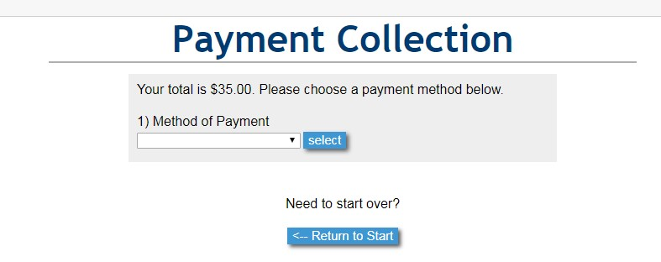

When you are fingerprinted, you will get a receipt. Please submit the receipt to Jolene Croteau for reimbursement. Reimbursements will be completed via check.
Should you have any questions, please contact Jolene Croteau at jcroteau@andover.edu or 978-749-4406

