Hello Summer Session employees,
If you are new to working in the Summer at Andover, or it has been 3 years since your last fingerprinting for Andover, you are required under Massachusetts law to submit your fingerprints for a background check. (Note: Returning faculty who were fingerprinted in 2019 or earlier must submit a new set of fingerprints prior to the start of the summer.) This process must be completed in Massachusetts at one of the 34 designated locations across the state. As you can imagine, organizing this for the large number of faculty coming each summer can be a challenge. Please read carefully to find more specific information in the bullets below:

❒ For all new faculty or returning faculty who are coming up on 3 years since the last set of fingerprints was submitted…
- You must sign up no later than June 13th, 2022, following the directions for online registration below.
- You must pay for the fingerprinting ($35) when you sign up. You MUST also keep and submit the receipt in order for us to reimburse you for the fee. Taking a picture and submitting a pdf of the receipt is also acceptable.
- You must bring an unexpired picture ID (driver’s license or passport for most) to your fingerprinting appointment.

❒ For Massachusetts residents (or those who attend school in Massachusetts)…
- Please arrange to have this done at the time and location that is most convenient to you. The list of locations and their available hours can be found here
(http://www.identogo.com/fp/massachusetts.aspx). Please follow the directions below to register for an appointment at your convenience.
- This must be completed before you arrive on campus for faculty orientation.
- We recommend signing up soon, as the available time slots fill up quickly.

❒ For those who do not live or go to school in Massachusetts…
- If you live or attend school in a neighboring state and can make a trip to Massachusetts for fingerprinting prior to orientation, please follow the directions above.
- If you live too far away from Massachusetts to make a trip here for fingerprinting, but you are bringing a car to campus, you will need to arrange to have your fingerprinting done on Wednesday, June 22, 2022 Between 3:30 – 5pm The closest fingerprinting location is Chelmsford.
- If you live too far away from Massachusetts to make a trip here for fingerprinting, and are not bringing a car to campus, we will be able to coordinate a limited number of van trips for fingerprinting. We ask that you go online – using the directions below– and sign up for a time on Thursday, June 23, 2022 between 4pm - 6pm (please choose the earliest time available) at the Chelmsford location.
- Once you have registered for a time slot, and no later than June 13th , please email Jolene with the following information:
  - Time of your appointment
  - Payment receipt for reimbursement
  - If you have your own car to drive to/from the appointment
We appreciate your timely attention to this important employment matter. Please don’t hesitate to contact us with any questions.
-Jolene and Beth
FINGERPRINTING APPOINTMENT INSTRUCTIONS
To schedule your appointment, follow the instructions below.
Go to: http://www.identogo.com/FP/Massachusetts.aspx
Select: Digital Fingerprinting
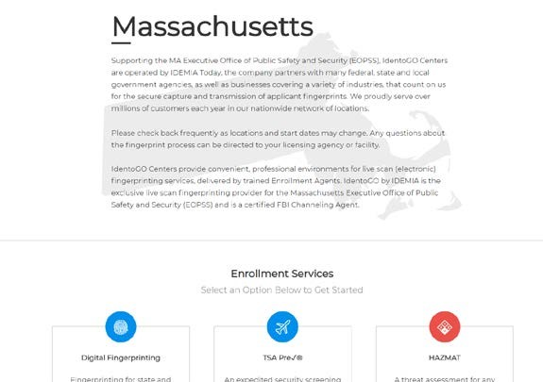
Select “Schedule a New Appointment”

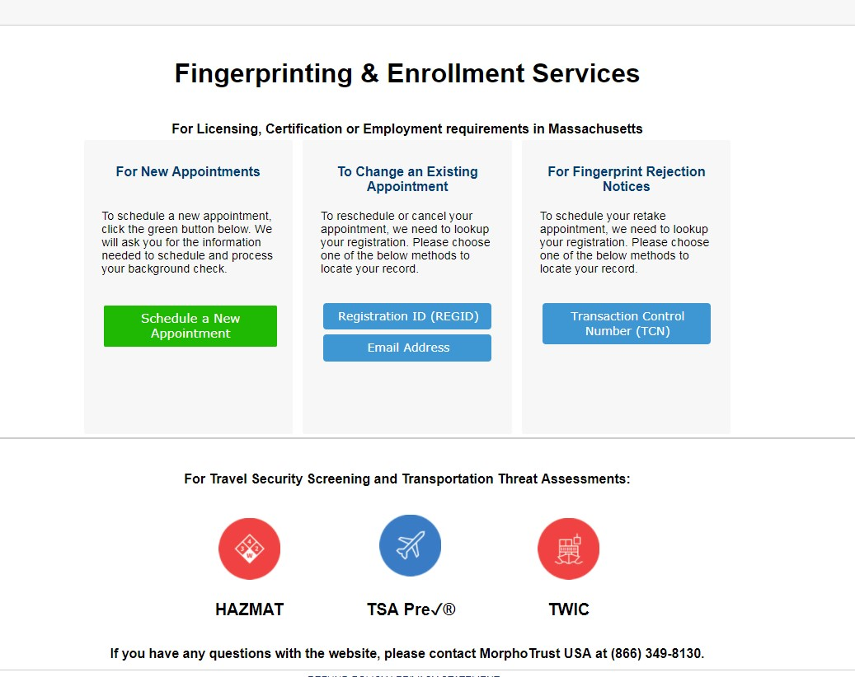
From the drop down menu, select Pre-K-12th Grade Education (ESE)
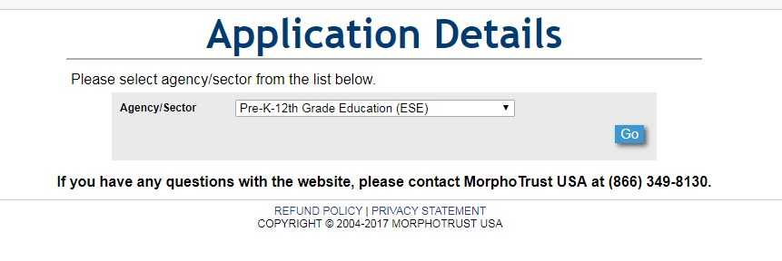
If you are a license educator, please select Licensed Educator, if not, select all other school personnel and select Go.
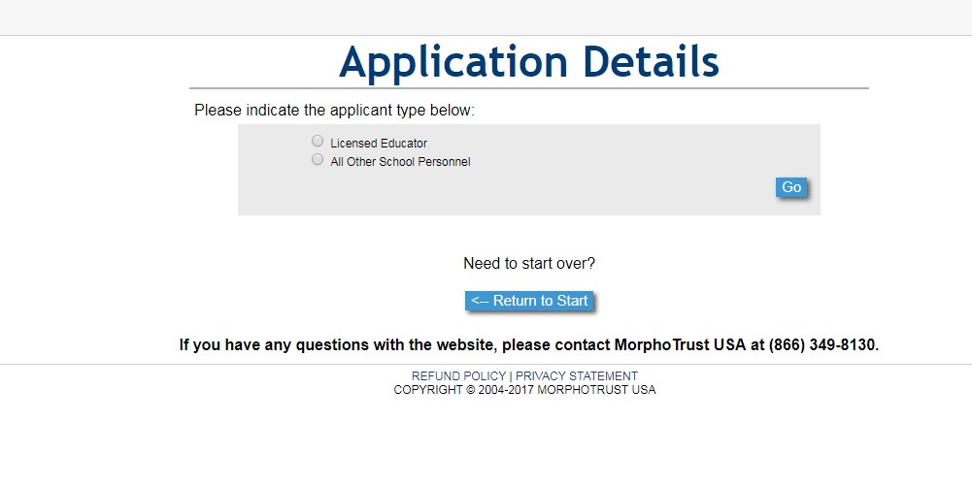
Confirm that you have selected the correct applicant type:
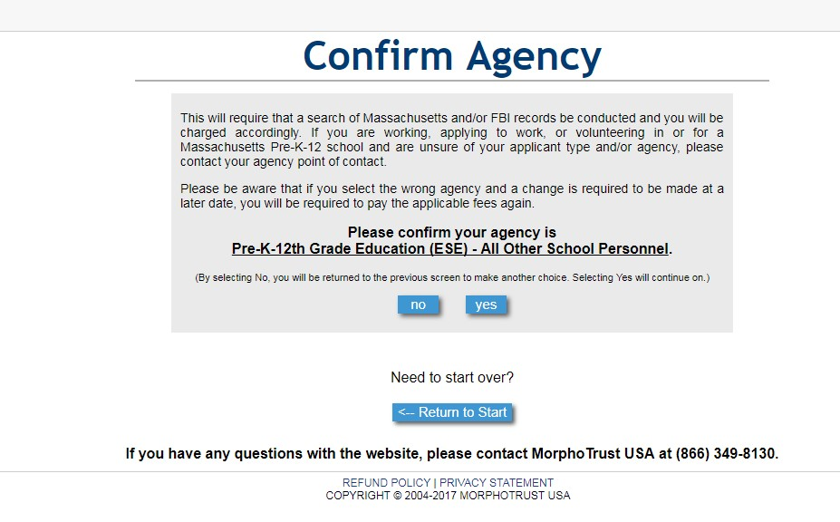

Enter the Provider ID of Phillips Academy: 00090820 then click add provider
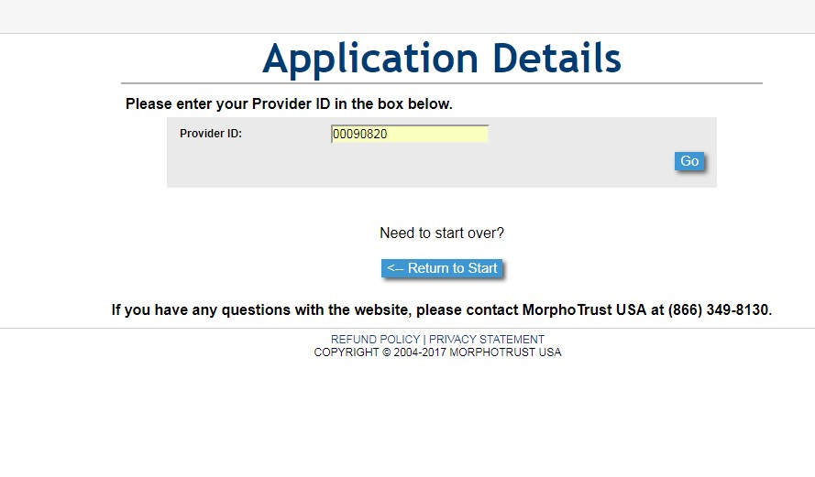
Confirm provider by selecting correct if it shows that Phillips Academy was selected:
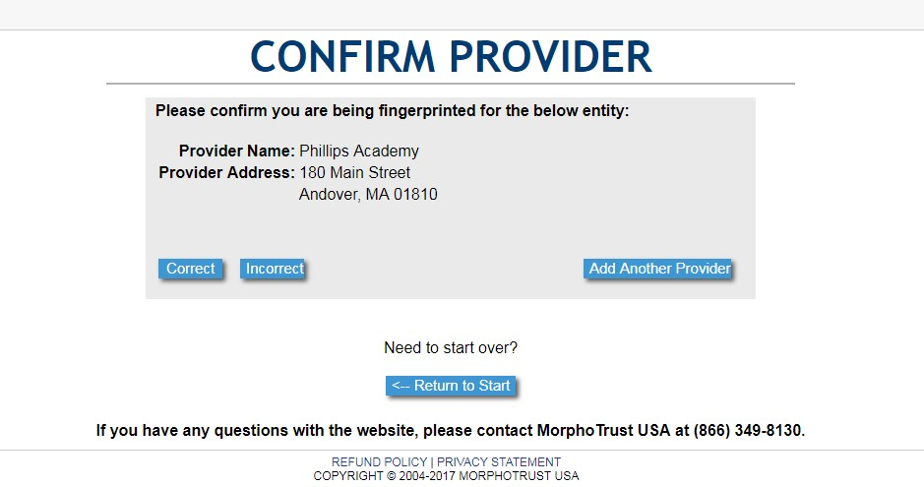
Enter zip code or select area in Massachusetts that you are in to locate the closest fingerprinting location:
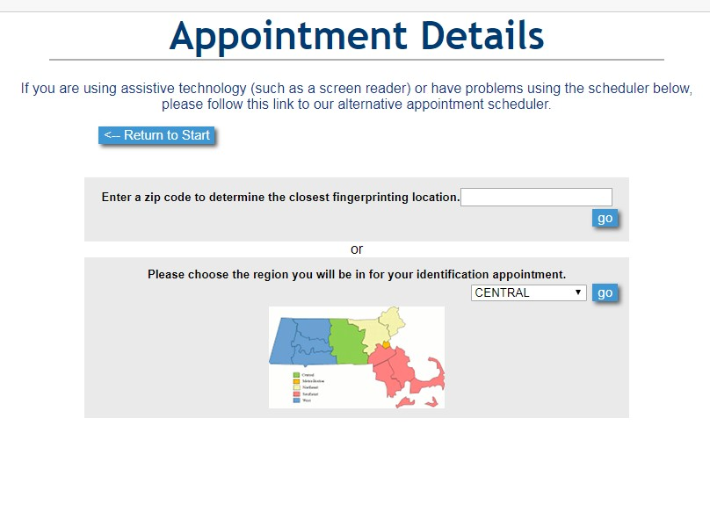
You will now have the option of selecting the date by navigating through dates/weeks by selecting “next week” at the top of the screen. By selecting next near viewing page at bottom of screen, you will be taken to different locations.
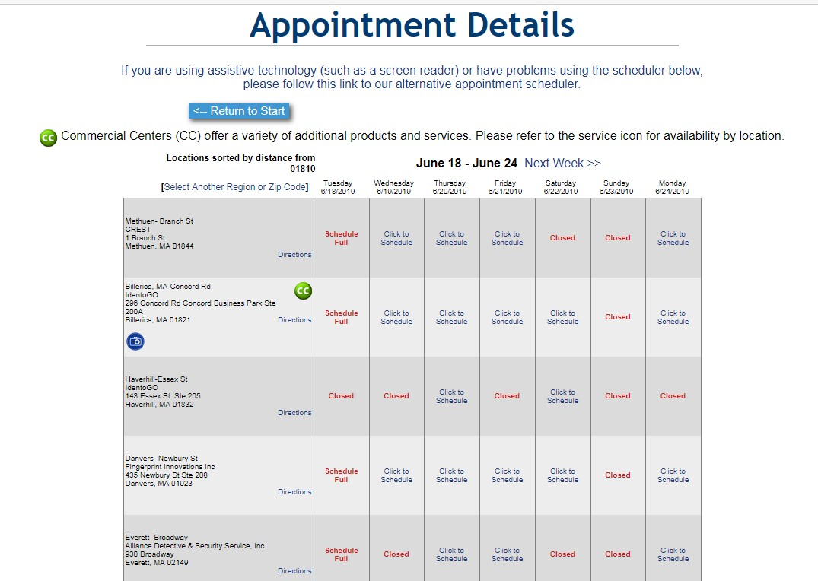
Select “click to schedule” to see options for different appointment times.
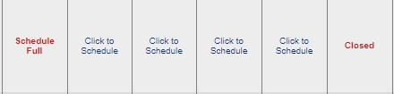
Read acknowledgement/Release and select appropriate box:
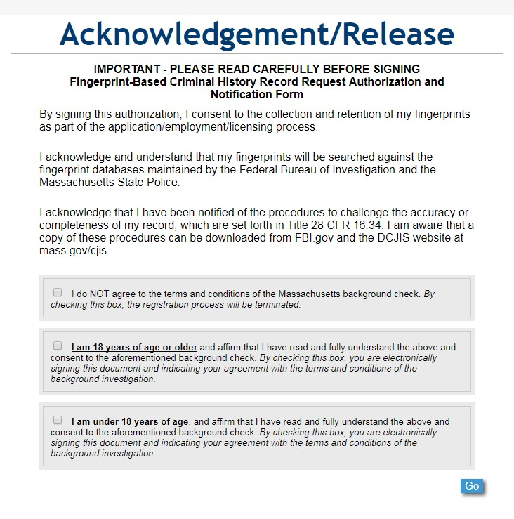
Complete the application information

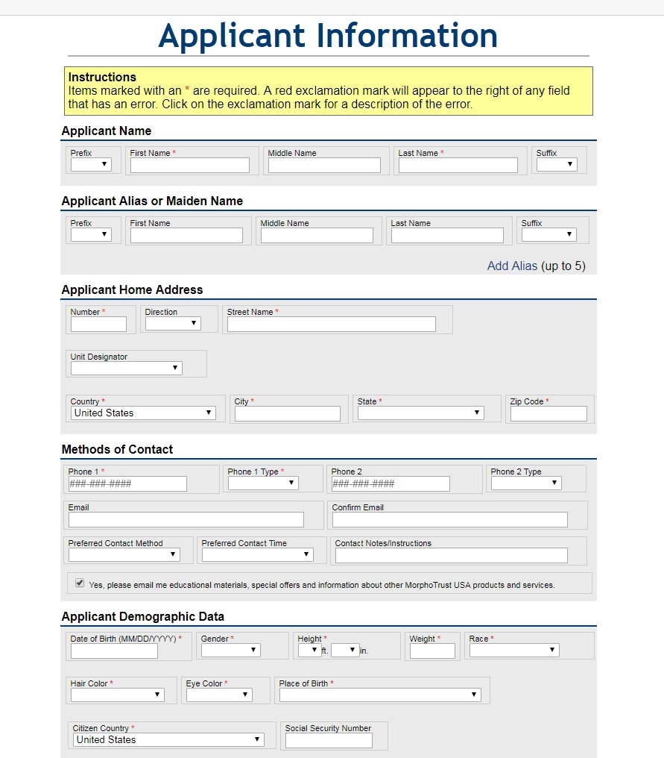

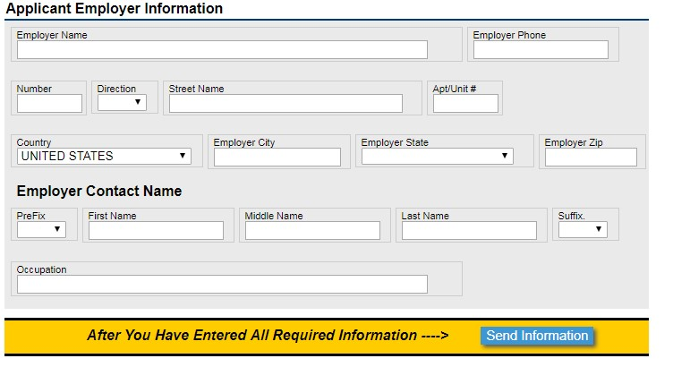

Select send information.

You will confirm the accuracy of your information as well as the location of the fingerprinting site on the next page. Once you have confirmed all is correct, select go. If there is anything incorrect, edit that section.

From the drop down options, select the method of payment.

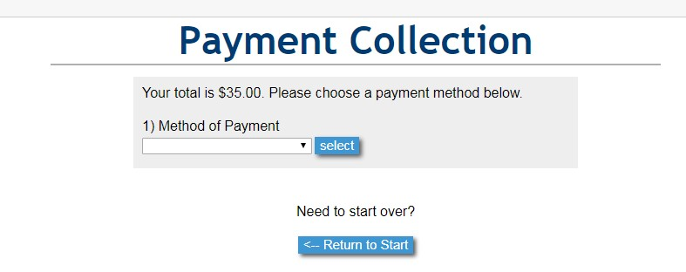

When you are fingerprinted, you will get a receipt. Please submit the receipt to Human Resources for reimbursement.

Should you have any questions, please contact Barbara Sweeney at 978-749-4107.

