Course Home Page planner

Course Name
Buttons
Across the top of the page, insert one button for each Learning Goal (linked to those pages in Canvas) plus an initial button for Orientation (we will provide a basic page with activities, and you can then customize to add links to your baseline assessment, course-specific orientation assignments, 1:1 Learning Conference scheduler, etc).

Welcome video
Create and insert a video introduction to the course – this is what students will interact with first, so make it fun! Introduce yourself, explain your course goals and how this crazy experiment will work, and what they need to do between now and your first group meeting.

Course Overview
Insert description of course and its goals here, along with the following paragraph:
“This summer, you'll be moving through the Learning Goals listed above at your own pace, in your own way, following your own Personalized Learning Plan. We will work together in our first 1:1 Learning Conference to create this plan, and from there, you'll be able to dive into each of the units above to begin your work towards mastery of the Learning Goals.”

Contact Information
Your name
email address
Zoom number
Calendly link
Best time to reach you

Schedule and Calendar
Weekly synchronous class meeting: DATE & TIME (with link and passcode)
Weekly 1:1 Learning Conferences: To be scheduled individually using THIS LINK
Weekly Office Hours (with link and passcode)
Any important course events or deadlines
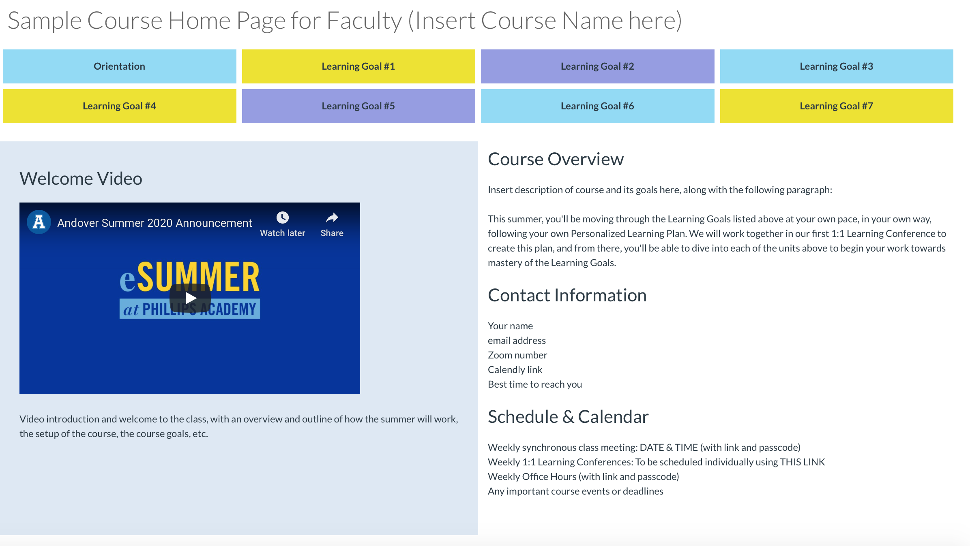

Learning Goal Home Page planner

Learning Goal Short Name
Optional: Buttons across the top linking to Success Indicator page

Embedded video, images, or other media
Ex: an overview video, key infographic about the concept, etc. Something worthy of being embedded on the page as the students’ very first introduction to the Learning Goal. Such as: https://www.thinglink.com/scene/796144622567948290

Learning Goal
Learning Goal Long Description.

Success Indicators
As needed, articulate the components of this Learning Goal to clarify what mastery will look like and what component parts students will need to master in order to achieve the overarching goal (you may want to embed your single-column rubric for this Learning Goal here).

Learning Resources
File name or URL | Linked Text
CentrifugalForce.PDF | What is Centrifugal Force?
https://www.youtube.com/watch?v=0L-foX49Row | 2 min video: “Centrifugal vs Centripetal, explained”
Difference.mp4 | 3 min video about CF vs CP
These should include a wide range of possible resources, from your own home-grown videos, to external videos, to uploaded texts, etc. Make sure the text clearly articulates what the resource is and what the focus topic is. If you want to get fancy, you could instead create separate Canvas pages for each Success Indicator and link them to the buttons at the top of the Learning Goal page, listing and linking learning resources there.

Student practice activities
List (and link) the options for student assignments here. These should include a range of possible activities, from writing prompts, problem sets, reading assignments & responses, discussions, video or photo uploads, partner projects, editing/revision, activities that can be done at home (like at-home experiments, simulations, demonstrations, etc.)

Demonstrating mastery
List (and link) the options for assessments here. These should include a range of possible activities, from formal tests/quizzes, final essay submission, video or photo uploads, etc.

